Department of Computer Technology
Vision Statement of the Department.
To be a preferred hub for nurturing computer engineering aspirants through innovative, ethical, value-based technical education, impactful research, and industry collaboration, to become successful professionals contributing for the betterment of society.
Mission Statement of the Department.
To nurture computer engineering professionals by offering Dynamic learning environment that encourages problem-solving using emerging technology, National Education Policy aligned evidence-based technical education, fostering ,innovation, research, and industry–institute collaboration & Holistic, ethical and sustainable development for lifelong success.

Session 2026-2027

Vision:Dream of where you want. | Mission: Means to achieve Vision

Program Educational Objectives of the program (PEO): (broad statements that describe the professional and career accomplishments)
PEO1 | Preparation | P: Preparation | Pep-CL abbreviation
PEO2 | Core Competence | E: Environment (Learning Environment) | pronounce as Pep-si-lL easy to recall
PEO3 | Breadth | P: Professionalism | pronounce as Pep-si-lL easy to recall
PEO4 | Professionalism | C: Core Competence | pronounce as Pep-si-lL easy to recall
PEO5 | Learning Environment | L: Breadth (Learning in diverse areas) | pronounce as Pep-si-lL easy to recall

Program Outcomes (PO): (statements that describe what a student should be able to do and know by the end of a program)

Keywords of POs:
Engineering knowledge,Problem analysis, Design/development of solutions,Conduct Investigations of Complex Problems, Engineering Tool Usage, The Engineer and The World,Ethics, Individual and Collaborative Team work,Communication, Project Management and Finance, Life-Long Learning

PSO Keywords: Cutting edge technologies, Research

“I am an engineer, and I know how to apply engineering knowledge to investigate, analyse and design solutions to complex problems using tools for entire world following all ethics in a collaborative way with proper management skills throughout my life.” to contribute to the development of cutting-edge technologies and Research.

Integrity: I will adhere to the Laboratory Code of Conduct and ethics in its entirety.

Name and Signature of Student and Date
(Signature and Date in Handwritten)

Department of Computer Technology
Vision Statement of the Department.
To be a preferred hub for nurturing computer engineering aspirants through innovative, ethical, value-based technical education, impactful research, and industry collaboration, to become successful professionals contributing for the betterment of society.
Mission Statement of the Department.
To nurture computer engineering professionals by offering Dynamic learning environment that encourages problem-solving using emerging technology, National Education Policy aligned evidence-based technical education, fostering ,innovation, research, and industry–institute collaboration & Holistic, ethical and sustainable development for lifelong success.

Session | 2026-27 |  | Course Name | Web Technology Lab
Semester | 3 |  | Course Code | 23CT1301
Roll No | 69 |  | Name of Student | Vinit Bagwe
Practical Number |  | 1-(B)
Course Outcome |  | - Understand various internet technologies.  - Design the web pages using HTML and CSS.  - Implement the XML technology to store the data.  - Develop the interactive web pages using JavaScript.
Aim |  | Study HTML tags and to implement create basic web page.
Problem Definition |  | To study the basic structure of HTML documents, explore standard HTML5 semantic elements (such as <header>, <nav>, <article>, <section>, <aside>, and <footer>), and build a functional web page using proper markup syntax.
Theory  (100 words) |  | HTML (HyperText Markup Language) defines the structure and layout of a web page using tags. The basic building blocks include <!DOCTYPE html> to specify HTML5,  <html> as the root element, <head> for metadata, and <body> for visible content.  HTML5 introduces modern features like semantic elements (<header>, <nav>,  <article>, <section>, <aside>, <footer>) to improve structural clarity. It also features built-in media elements (<audio>, <video>), persistent local storage, canvas drawing, and cleaner syntax rules (such as simplified doctype and character encoding declarations like <meta charset="UTF-8">)

Department of Computer Technology
Vision Statement of the Department.
To be a preferred hub for nurturing computer engineering aspirants through innovative, ethical, value-based technical education, impactful research, and industry collaboration, to become successful professionals contributing for the betterment of society.
Mission Statement of the Department.
To nurture computer engineering professionals by offering Dynamic learning environment that encourages problem-solving using emerging technology, National Education Policy aligned evidence-based technical education, fostering ,innovation, research, and industry–institute collaboration & Holistic, ethical and sustainable development for lifelong success.
Procedure and Execution | Step for Implementation:  - Open a text editor (such as VS Code, Sublime Text, or Notepad).  - Create a new file and save it as index.html.  - Add the HTML5 boilerplate structure using <!DOCTYPE html>, <html>,  <head>, and <body> tags.  - Set the document title in the <title> tag and include the <meta charset="utf-8"> encoding tag inside <head>.  - Build the visible section using HTML5 semantic elements: <header> for the top heading, <nav> for navigation links, <article> and <section> for content,  <aside> for extra details, and <footer> for author info.  - Save the file and open it in any modern browser (Chrome, Firefox, Safari) to view the rendered page.
(100 Words)
 | Code:
<!DOCTYPE html>
<html>
<head>
<meta charset="utf-8">
<title>HTML5 Basic Web Page</title>
</head>
<body>
<header role="banner">
<h1>HTML5 Document Structure Example</h1>
<p>This page should be tried in safari, chrome or Mozilla.</p>
</header>
<nav>
<ul>
<li><a href="https://infyspringboard.onwingspan.com">HTML Tutorial</a></li>
<li><a href="https://infyspringboard.onwingspan.com">CSS Tutorial</a></li>
<li><a href="https://infyspringboard.onwingspan.com">JavaScript Tutorial</a></li>
</ul>
</nav>

Department of Computer Technology
Vision Statement of the Department.
To be a preferred hub for nurturing computer engineering aspirants through innovative, ethical, value-based technical education, impactful research, and industry collaboration, to become successful professionals contributing for the betterment of society.
Mission Statement of the Department.
To nurture computer engineering professionals by offering Dynamic learning environment that encourages problem-solving using emerging technology, National Education Policy aligned evidence-based technical education, fostering ,innovation, research, and industry–institute collaboration & Holistic, ethical and sustainable development for lifelong success.
<article>
<section>
<p>One article can have multiple sections</p>
</section>
</article>
<aside>
<p>This is aside part of the web page</p>
</aside>
<footer>
<p>Created by <a href="https://infyspringboard.onwingspan.com">Limay</a></p>
</footer>
</body>
</html>
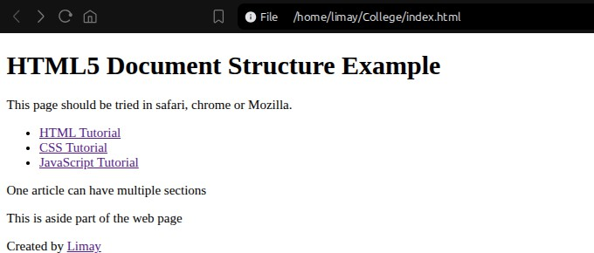

 | Output:
Output Analysis | The web browser successfully interpreted the HTML5 tags and organized the content into clear, distinct sections (Header, Navigation, Article, Aside, and Footer) according to the semantic structure.

Department of Computer Technology
Vision Statement of the Department.
To be a preferred hub for nurturing computer engineering aspirants through innovative, ethical, value-based technical education, impactful research, and industry collaboration, to become successful professionals contributing for the betterment of society.
Mission Statement of the Department.
To nurture computer engineering professionals by offering Dynamic learning environment that encourages problem-solving using emerging technology, National Education Policy aligned evidence-based technical education, fostering ,innovation, research, and industry–institute collaboration & Holistic, ethical and sustainable development for lifelong success.
Link of student Github profile where lab assignment has been uploaded | https://github.com/vinitbagwe10-cmd
Conclusion | Successfully studied basic HTML tags and built a structured, functional web page using modern HTML5 structural elements.
Plag Report (Similarity index < 12%) | 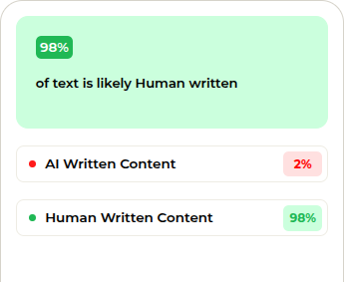
Date | 07/07/2026

